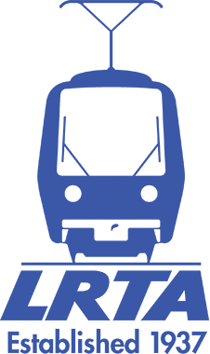

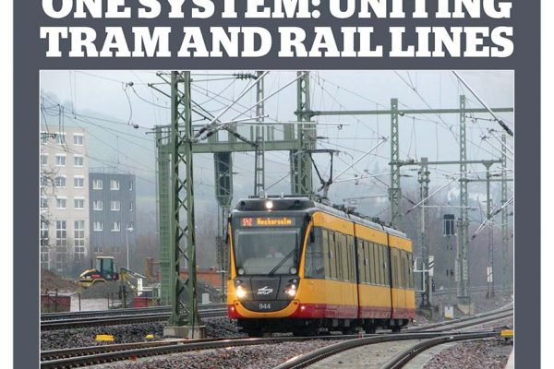

- AbWhy Join LRTA

Why Join LRTA - The Light Rail Transit Association (Click through to www.lrta.org )

If you wish to see improved public transport in our cities, then you should join the LRTA — the more members the more effective we can be in campaigning for the introduction of trams and light rail.
Members receive T&UT as part of their subscription, at a discount on the cover price. There is now a choice of postal or online versions of the magazine. Postal subscribers can also access the online version.
Membership includes access to the LRTA e–Group; a IO group. You can join online at the LRTA shop by clicking the Discussion Group item on the join/renewals page. Alternatively to join please e–mail groups@lrta.org; include your full name, membership number and post/zip code to ease the task of checking membership.

MEMBER’S DAYS
Member’s Days are held from time to time to offer Members to opportunity for a Presentation and Visit to recent developments in Light Rail and trams.
The latest Members Day was on the Tyne And Wear Metro on 12 July 2021 in Newcastle/Gateshead. Go to the Members’ Days page for details .
Members also have access to a Members Area which enables members to read the magazine on-line plus a selection of internal documents not available to the general public including a special guide to campaigning. When logged in a members discount is available on books and DVDs. To access go to the LRTA shop and create/log in to your account. Email OLM@lrta.org if Members Area not visible.

Keep in touch – e-mail updates
We believe that keeping in touch with the latest news, campaigns, meetings, and publications from the LRTA is important, and we would like to further strengthen the links with our members and supporters. Update your email now.
Personal Membership from £37.50p (See joining Form for variable rates)
Personal membership subscriptions run for one year from the date of acceptance of your membership application. All members get our monthly magazine Tramways and Urban Transit as part of their membership and can also subscribe to our historical journal Tramway Review. Back numbers of both publications are available from our shop see Back Numbers. There is a choice of postal or on–line versions of the magazine. Postal subscribers can also access the online version. Join With Personal Membership
Student Membership
Student membership is available to anyone up to the age of 25 who is in full or part time education, or a work-related training scheme in the public transport industry including suppliers of goods and services. This reduced price is only available online. Join With Student Membership

Business Subscriptions
Subscriptions paid by companies or other business employers on behalf of their employees; can be invoiced to the company or organisation concerned. Contact the Membership Secretary for details of Commercial membership.
Enquire about Commercial Membership
Any Membership Questions:
Email membership@lrta.org
or phone 0117 951 7785

Contact Us

