Schweizer Electronics supports and sponsors the
All Party Parliamentary Light Rail Group
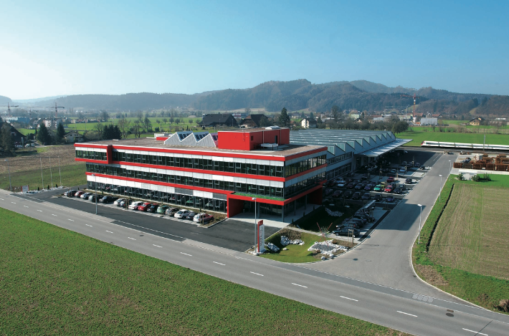 | Schweizer Electronic is the market leader in Europe for on track automated protection on busy railways for both passenger and freight lines.  Railway automation and high-availability radio systems complement the product range and market segments.
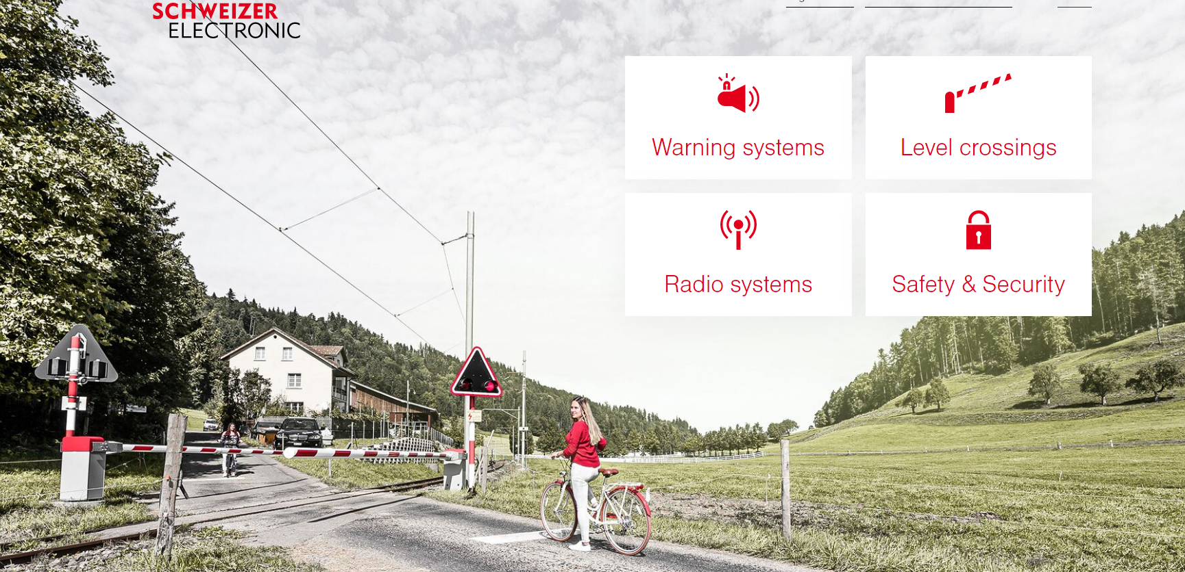

The environment is important to us!
Implementing a strong and robust environmental policy that has clear objectives and monitoring, the extent to which we can demonstrate how our environmental objectives have been achieved.
We aim to mitigate climate change by avoiding or reducing greenhouse gas emissions or by complying with climate-friendly policies to reduce the net contribution to climate change
We do our best to protect the environment through professional disposal and environmentally friendly consumption of resources (e.g., rainwater instead of fresh water as rinsing water).
Integration of environmental aspects and principles of sustainable development in product development.
We comply with the environmental standards of each country in which we operate.

